Web Application Basics

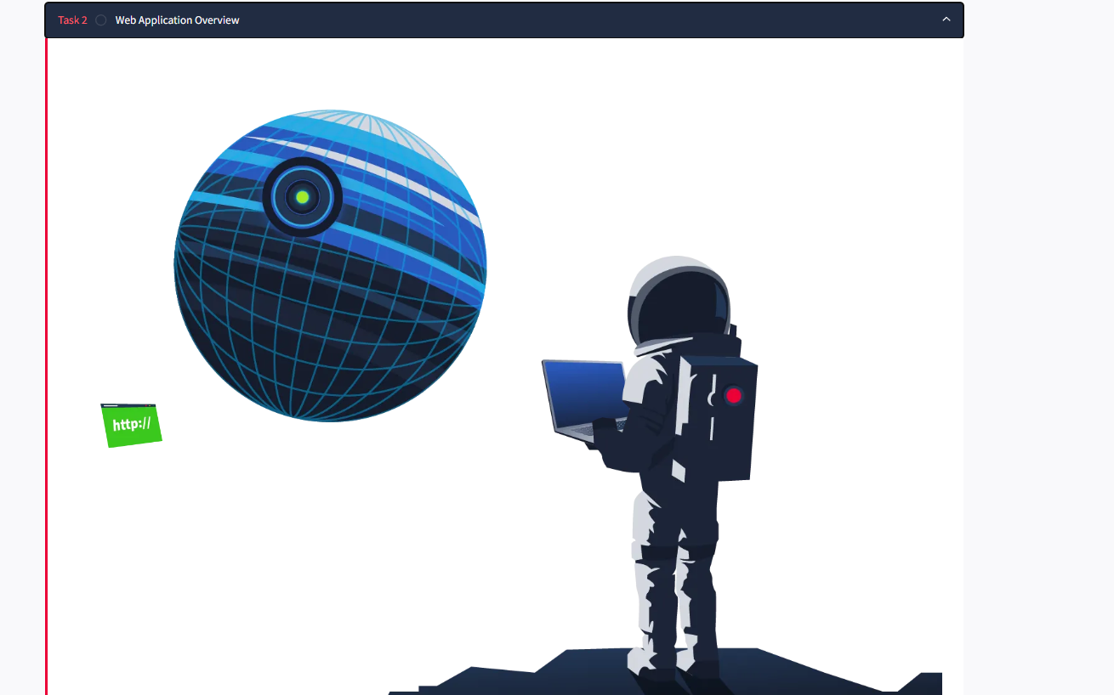

Consider an analogy of a web application as a planet. Astronauts travel to the planet to explore its surface, similar to how someone uses a web browser to explore or browse a web application. Although we only see the surface of a planet, a lot is going on under the surface. You can imagine the whole planet as a web server with many things going on under the surface of the web server, yet all we can usually see is the surface of web pages or apps. We will now explore the various components that make up a web application.

Front End
The Front End can be considered similar to the surface of the planet, the parts that an astronaut can see and interact with based on the laws of nature. A web application would have a user interact with it and use a number of technologies such as HTML, CSS, and JavaScript to do this.
HTML (Hypertext Markup Language) is a foundational aspect of web applications. It is a set of instructions or code that instructs a web browser on what to display and how to display it. It could be compared to simple organisms living on the planet; these organisms have DNA, which is the instructions for how simple organisms are put together.

CSS (Cascading Style Sheets) in web applications describes a standard appearance, such as certain colours, types of text, and layouts. Continuing the analogy with DNA, these could be compared to the parts of DNA that describe the colour, shape, size, and texture of the simple organism.

JS (JavaScript) is part of a web application front end that enables more complex activity in the web browser. Whereas HTML can be considered a simple set of instructions on what to display, JavaScript is a more advanced set of instructions that allows choices and decisions to be made on what to display. In the planet analogy, JavaScript can be considered the brain of an advanced organism, which allows decisions to be made based on what and how something interacts with it.

Back End
The Back End of a web application is things you don’t see within a web browser but are important for the web application to work. On a planet, these are the non-visual things: the structures that keep a building standing, the air, and the gravity that keeps feet on the ground.

A Database is where information can be stored, modified, and retrieved. A web application may want to store and retrieve information about a visitor's preferences on what to show or not; this would be stored in a database. A planet may have more advanced inhabitants who store information about locations in maps, write notes in a diary or put books in a library and files in a filing cabinet.

There are many other Infrastructure components underpinning Web Applications, such as web servers, application servers, storage, various networking devices, and other software that support the web application. On a planet, these are the roads that are present, the cars that run on those roads, the fuel that powers the cars.

WAF (Web Application Firewall) is an optional component for web applications. It helps filter out dangerous requests away from the Web Server and provides an element of protection. This could be considered similar to how a planet's atmosphere can protect inhabitants from harmful UV rays.

URL
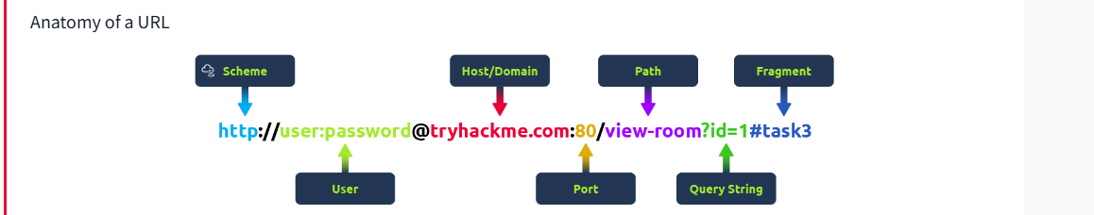

Uniform Resource Locator
A Uniform Resource Locator (URL) is a web address that lets you access all kinds of online content—whether it’s a webpage, a video, a photo, or other media. It guides your browser to the right place on the Internet.

Anatomy of a URL

Think of a URL as being made up of several parts, each playing a different role in helping you find the right resource. Understanding how these parts fit together is important for browsing the web, developing web applications, and even troubleshooting problems.
Here’s a breakdown of the key components:
Scheme
The scheme is the protocol used to access the website. The most common are HTTP (HyperText Transfer Protocol) and HTTPS (Hypertext Transfer Protocol Secure). HTTPS is more secure because it encrypts the connection, which is why browsers and cyber security experts recommend it. Websites often enforce HTTPS for added protection.
User
Some URLs can include a user’s login details (usually a username) for sites that require authentication. This happens mostly in URLs that need credentials to access certain resources. However, it’s rare nowadays because putting login details in the URL isn’t very safe—it can expose sensitive information, which is a security risk.
Host/Domain
The host or domain is the most important part of the URL because it tells you which website you’re accessing. Every domain name has to be unique and is registered through domain registrars. From a security standpoint, look for domain names that appear almost like real ones but have small differences (this is called typosquatting). These fake domains are often used in phishing attacks to trick people into giving up sensitive info.
Port
The port number helps direct your browser to the right service on the web server. It’s like telling the server which doorway to use for communication. Port numbers range from 1 to 65,535, but the most common are 80 for HTTP and 443 for HTTPS.
Path
The path points to the specific file or page on the server that you’re trying to access. It’s like a roadmap that shows the browser where to go. Websites need to secure these paths to make sure only authorised users can access sensitive resources.
Query String
The query string is the part of the URL that starts with a question mark (?). It’s often used for things like search terms or form inputs. Since users can modify these query strings, it’s important to handle them securely to prevent attacks like injections, where malicious code could be added.
Fragment
The fragment starts with a hash symbol (#) and helps point to a specific section of a webpage—like jumping directly to a particular heading or table. Users can modify this too, so like with query strings, it’s important to check and clean up any data here to avoid issues like injection attacks.

HTTP messages are packets of data exchanged between a user (the client) and the web server. These messages are very important for understanding how web applications work because they show how users' requests and the server's responses are communicated.
Imagine an example of an HTTP Request and an HTTP Response, where you can see key parts like the method, URL, headers, and status codes. These are what make the client-server interaction possible.
There are two types of HTTP messages:
- HTTP Requests: Sent by the user to trigger actions on the web application.
- HTTP Responses: Sent by the server in response to the user’s request.

Each message follows a specific format that helps both the user and the server communicate smoothly.
Start Line
The start line is like the introduction of the message. It tells you what kind of message is being sent—whether it's a request from the user or a response from the server. This line also gives important details about how the message should be handled.
Headers
Headers are made up of key-value pairs that provide extra information about the HTTP message. They give instructions to both the client and the server handling the request or response. These headers cover all sorts of things, like security, content types, and more, making sure everything goes smoothly in the communication.
Empty Line
The empty line is a little divider that separates the header from the body. It’s essential because it shows where the headers stop and where the actual content of the message begins. Without this empty line, the message might get messed up, and the client or server could misinterpret it, causing errors.
Body
The body is where the actual data is stored. In a request, the body might include data the user wants to send to the server (like form data). In a response, it’s where the server puts the content that the user requested (like a webpage or API data).

Why Understanding HTTP Messages Matters
- These messages are the foundation of how web applications communicate. If they’re structured properly, everything works smoothly.
- Knowing how they work will help you diagnose issues in web communication, which means better performance and reliability for your web application.
- It’s also crucial for security. Understanding HTTP messages helps you implement strong security measures to protect data during transmission.

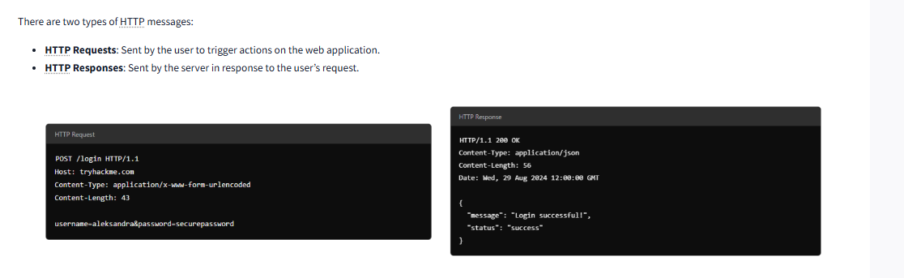

HTTP Request : Request Line and Methods

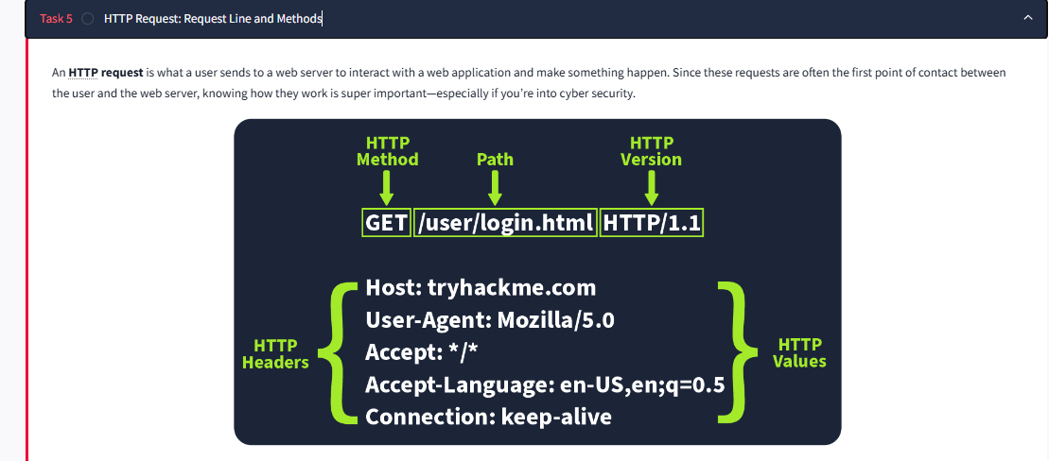

An HTTP request is what a user sends to a web server to interact with a web application and make something happen. Since these requests are often the first point of contact between the user and the web server, knowing how they work is super important—especially if you’re into cyber security.

Imagine an HTTP request showing the key parts like the method (e.g., GET or POST), path (e.g., /login), and version (e.g., HTTP/1.1). These elements make up the basics of how a client (user) communicates with a server.

Request Line
The request line (or start line) is the first part of an HTTP request and tells the server what kind of request it’s dealing with. It has three main parts: the HTTP method, the URL path, and the HTTP version.
Example: METHOD /path HTTP/version

HTTP Methods
The HTTP method tells the server what action the user wants to perform on the resource identified by the URL path. Here are some of the most common methods and their possible security issue:
GET
Used to fetch data from the server without making any changes. Reminder! Make sure you’re only exposing data the user is allowed to see. Avoid putting sensitive info like tokens or passwords in GET requests since they can show up as plaintext.
POST
Sends data to the server, usually to create or update something. Reminder! Always validate and clean the input to avoid attacks like SQL injection or XSS.
PUT
Replaces or updates something on the server. Reminder! Make sure the user is authorised to make changes before accepting the request.
DELETE
Removes something from the server. Reminder! Just like with PUT, make sure only authorised users can delete resources.
Besides these common methods, there are a few others used in specific cases:
PATCH
Updates part of a resource. It’s useful for making small changes without replacing the whole thing, but always validate the data to avoid inconsistencies.
HEAD
Works like GET but only retrieves headers, not the full content. It’s handy for checking metadata without downloading the full response.
OPTIONS
Tells you what methods are available for a specific resource, helping clients understand what they can do with the server.
TRACE
Similar to OPTIONS, it shows which methods are allowed, often for debugging. Many servers disable it for security reasons.
CONNECT
Used to create a secure connection, like for HTTPS. It’s not as common but is critical for encrypted communication.
Each of these methods has its own set of security rules. For example, PATCH requests should be validated to avoid inconsistencies, and OPTIONS and TRACE should be turned off if not needed to avoid possible security risks.

URL Path
The URL path tells the server where to find the resource the user is asking for. For instance, in the URL https://tryhackme.com/api/users/123, the path /api/users/123 identifies a specific user.
Attackers often try to manipulate the URL path to exploit vulnerabilities, so it’s crucial to:
- Validate the URL path to prevent unauthorised access
- Sanitise the path to avoid injection attacks
- Protect sensitive data by conducting privacy and risk assessments
Following these practices helps protect your web application from common attacks.

HTTP Version
The HTTP version shows the protocol version used to communicate between the client and server. Here’s a quick rundown of the most common ones:
HTTP/0.9 (1991)
The first version, only supported GET requests.
HTTP/1.0 (1996)
Added headers and better support for different types of content, improving caching.
HTTP/1.1 (1997)
Brought persistent connections, chunked transfer encoding, and better caching. It’s still widely used today.
HTTP/2 (2015)
Introduced features like multiplexing, header compression, and prioritisation for faster performance.
HTTP/3 (2022)
Built on HTTP/2, but uses a new protocol (QUIC) for quicker and more secure connections.
Although HTTP/2 and HTTP/3 offer better speed and security, many systems still use HTTP/1.1 because it’s well-supported and works with most existing setups. However, upgrading to HTTP/2 or HTTP/3 can provide significant performance and security improvements as more systems adopt them.
Answer the questions below
Which HTTP protocol version became widely adopted and remains the most commonly used version for web communication, known for introducing features like persistent connections and chunked transfer encoding?

Submit
Which HTTP request method describes the communication options for the target resource, allowing clients to determine which HTTP methods are supported by the web server?

Submit
In an HTTP request, which component specifies the specific resource or endpoint on the web server that the client is requesting, typically appearing after the domain name in the URL?

Submit

HTTP Request : Headers and Body

Request Headers
Request Headers allow extra information to be conveyed to the web server about the request. Some common headers are as follows:

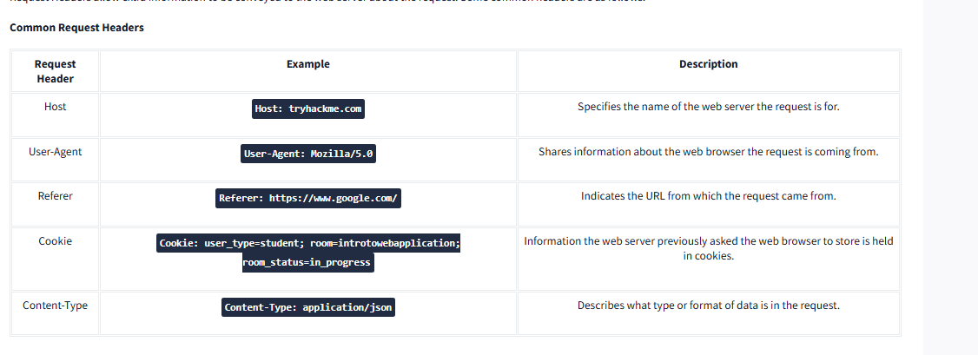

Request Body
In HTTP requests such as POST and PUT, where data is sent to the web server as opposed to requested from the web server, the data is located inside the HTTP Request Body. The formatting of the data can take many forms, but some common ones are URL Encoded, Form Data, JSON, or XML.
- URL Encoded (application/x-www-form-urlencoded)
A format where data is structured in pairs of key and value where (key=value). Multiple pairs are separated by an (&) symbol, such as key1=value1&key2=value2. Special characters are percent-encoded.
Example
POST /profile HTTP/1.1
Host: tryhackme.com
User-Agent: Mozilla/5.0
Content-Type: application/x-www-form-urlencoded
Content-Length: 33

name=Aleksandra&age=27&country=US
- Form Data (multipart/form-data)
Allows multiple data blocks to be sent where each block is separated by a boundary string. The boundary string is the defined header of the request itself. This type of formatting can be used to send binary data, such as when uploading files or images to a web server.
Example
POST /upload HTTP/1.1
Host: tryhackme.com
User-Agent: Mozilla/5.0
Content-Type: multipart/form-data; boundary=----WebKitFormBoundary7MA4YWxkTrZu0gW

----WebKitFormBoundary7MA4YWxkTrZu0gW
Content-Disposition: form-data; name="username"

aleksandra
----WebKitFormBoundary7MA4YWxkTrZu0gW
Content-Disposition: form-data; name="profile_pic"; filename="aleksandra.jpg"
Content-Type: image/jpeg

[Binary Data Here representing the image]
----WebKitFormBoundary7MA4YWxkTrZu0gW--
- JSON (application/json)
In this format, the data can be sent using the JSON (JavaScript Object Notation) structure. Data is formatted in pairs of name : value. Multiple pairs are separated by commas, all contained within curly braces { }.
Example
POST /api/user HTTP/1.1
Host: tryhackme.com
User-Agent: Mozilla/5.0
Content-Type: application/json
Content-Length: 62

{
"name": "Aleksandra",
"age": 27,
"country": "US"
}
- XML (application/xml)
In XML formatting, data is structured inside labels called tags, which have an opening and closing. These labels can be nested within each other. You can see in the example below the opening and closing of the tags to send details about a user called Aleksandra.
Example
POST /api/user HTTP/1.1
Host: tryhackme.com
User-Agent: Mozilla/5.0
Content-Type: application/xml
Content-Length: 124

<user>
<name>Aleksandra</name>
<age>27</age>
<country>US</country>
</user>

